
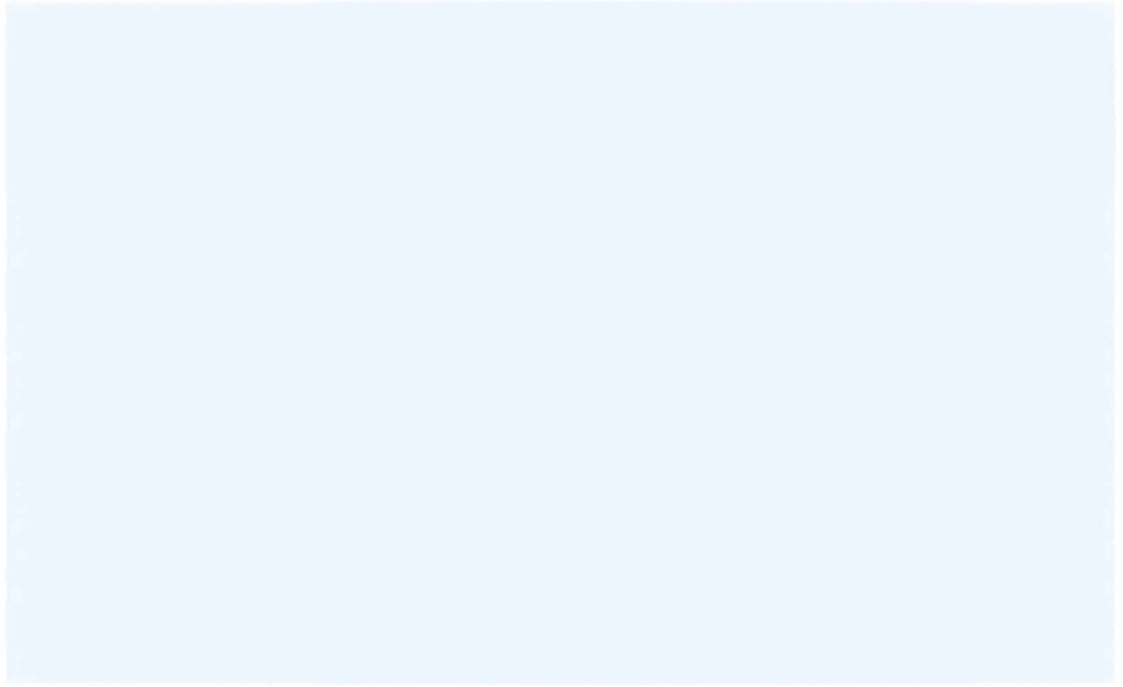


Selected Information Gathering Systems at the Univeristy of Utah*

April 27, 2015

* This report is submitted in partial satisfaction of the course requirements in UGS 2260-001 Block U: Privacy and Surveillance taught by Professors Randy Dryer and Sean Lawson in the 2014-15 academic year.

Group Members
Leo Antinozzi
Jordan Burringo
Carly Carlson
Stephany Cortez
Alex Dobesh
Atanaya Gross
Kaeli Heugly
Moevanu Jameson
Alex Oviatt
Cameron Redmond

Table of Contents

Introduction……………………………………………………………3

UCARDS………………………………………………………………4

Wifi and Internet Tracking………….…………………………………8

Data Warehouse……………………………………………………..…9

Parking Lots…………………………………………………………..11

Financial Aid and Scholarships……………………………………….13

A. Ray Olpin Student Union………………………………………….15

J. Willard Marriott Library……………………………………………17

Athletic Teams: Men’s Basketball…………………………………….21

Block U Program………………………………………………………25

School of Medicine: Learning Resource Center………………………26

Appendix A……………………………………………………………28

Introduction

With the ongoing revelations of former defense contractor, Edward Snowden, and other recent events surrounding the activities of the United States intelligence community in general, and the National Security Agency in particular have been under a lot of fire from some American citizens. PEW Research Center recently published a survey that showed that 17% of Americans claim to be “very concerned” about this surveillance, while 35% say that they are “somewhat concerned.” The government has been deemed overly invasive and people have begun doing things like creating stronger passwords, encrypting information on their computers and/or phones, or paying cash rather than using a credit card all in order to avoid government surveillance. Yet, intelligence agencies are not the only one collecting information. Even before this, the information age, universities have been a prime example of surveillance and information gathering systems. This report shows various information gathering systems at the University of Utah. Due to time constraints and manpower limitations, this report does not attempt to identify or discuss all the surveillance systems in operation at the University. A list of persons interviewed for this report is attached as Appendix A. We wish to thank those University employees and administrators for their openness in meeting with us.

UCARDs
The University of Utah UCARD offers one standardized source of identification and access for the institution ensuring convenience, security, simplicity. Ucard access is given to students, staff, and faculty. On the card, the information is the name, picture and a university number. The 16 digit number below the name of the student/faculty/staff that is their designated University number which never changes until the card is lost or stolen. The University of Utah UCard Office handles everything with the card, besides the information collected.
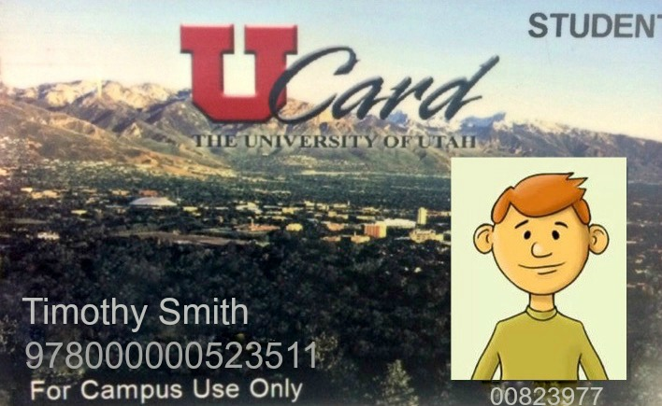
The information collected by the University maintains the privacy of student information and does not release any information except as permitted by the law. The University also contracts with third parties and federal laws prohibit third parties from releasing student-specific information to any other party and from using such information for any other purpose than that specified in the contract.

UCARDS are used all over campus. They all gather information separately. Everyone who is registered through the University of Utah has a UCARD and it lets students do several things such as:
- Library privileges
- Student priced tickets for campus events
- Student services and programs
- Campus Recreation privileges
- Meal plan paid as part of your residential living fees
- Door access to your dorm or other buildings on campus
- Campus Store discount for Students, Staff and Faculty
- Identification for the Testing Center
- Free tickets to events such as sporting events
- Utah Transit Authority Pass—public transportation
Here are three examples of things that students can use their UCARDS for:
1.Trax
- Trax Security collects the information at trax using the Tap on and Tap off electronic readers.
- Readers collect the information to know when someone gets on or off of the trax train. The tap records allow trax to construct trips for fare calculations.
- This information is collected by UTA because it’s an easier way to pay with a credit card or an easy way to use an accredited card.
- The information collected in not encrypted and they keep the information for 2 hours.
- They do not share the information with anyone.
2. Marriott Honors Community
- The Blackboard system is the campus system that is used for access in the residence halls. Within the Marriott Honors Community, we utilize this system in-door access to the building as well as in-door access from residential to nonresidential areas of the building. We also utilize the system in door access to specific rentals within the building, such as bike storage and rental storage space in the building. Individuals that pay for these rental services have access to them.
- The Blackboard system also connects with the Point of Sale registers that are utilized by University Dining Services. This system is utilized in the Marriott Honors Market.
- Within Housing & Residential Education there are layers of security in which various staff members have access to the information. This includes “view only” to a student/staff member’s general information to individuals who can run reports of access to buildings, to individuals who can change meal plans on student cards.
- Within University Dining Services, they have access to the information in regards to purchases made.
- Blackboard is accessed as a desktop computer program that has a separate login and is password protected.
- What they do with this information is dependent upon the staff member’s position and the situation at hand. Some ways the information is utilized include checking a student’s door access when a Welfare Check on a student is initiated. A door access report for a specific door may be utilized to help in the residential investigation of a student conduct situation.
- The information obtained is only kept in use until the student graduates or the staff member leaves the institution.
- We add access, remove access, or monitor reports as needed on a student’s UCard during their time with HRE. We add meal plan information or change meal plan information as needed on a student’s UCard during their time with HRE.
- HRE does not share a student’s information with entities not associated with HRE or the U in managing student access, meal plans, or crisis situations.
- A record is made in the system when a student opens a door or uses their meal plan. The information that is coded on to a student's card provides door access and meal privileges accordingly.

3. Student Life Center

- Cashiers and security collect the information at the Student Life Center using the tap of the card. (What information collected? Name, unit..)
- They use this information as payment/pass to get into the Student Life Center.
- They collect this information because it allows people to get into the Student Life Center and to pay.
- The information collected in not encrypted and they keep the information as long as your payment plan is or if it is for the cahiers use, only a day.
- They do not share the information with anyone.

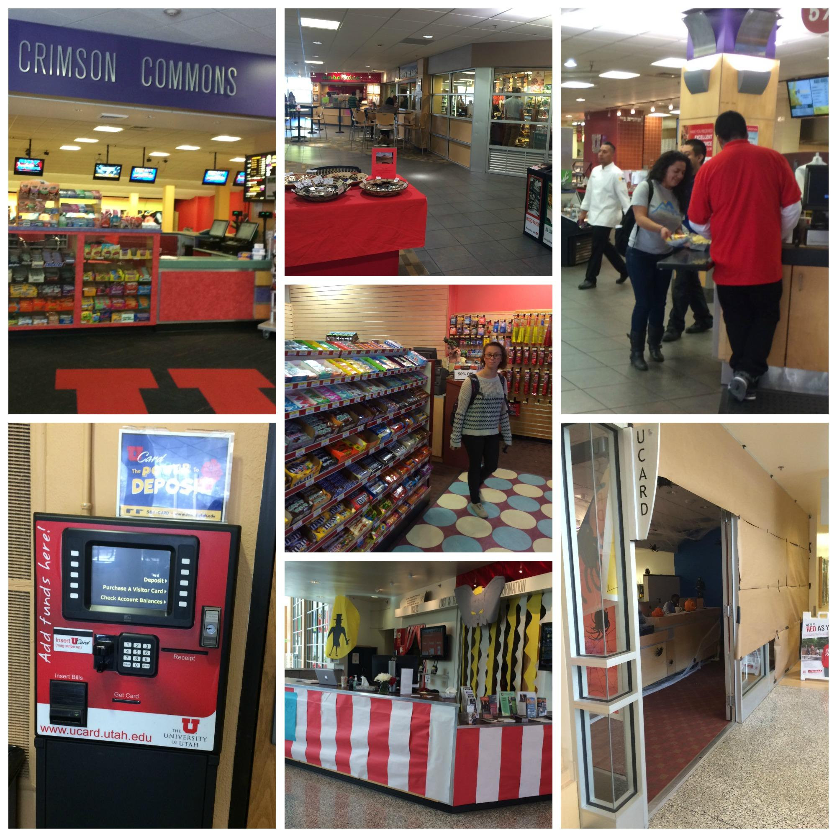
These photos show the various place where UCARDS are used in the A. Ray Olpin Student Union building.

Wifi and Internet Tracking
1. Wifi in general
- Constantly pings on mobile devices
- Searching for networks
- Location is always known
- Leads to location based advertising
- Wifi sniffers detect and record these pings
- Can build composite of habits
- Sniffers installed in retail stores
- Installed to detect location within stores
- Work regardless of whether or not wifi is on
- Devices MAC address does not change, meaning this tracking in a single devices is consistent regardless of which network
- A MAC address consists of 12 digits randomly generated that helps routers send data to the receiving device
- By logging these numbers, businesses log the devices
- Any connection over wifi can be collected by the wifi provider
- Social media information (Age, Gender, etc.)
- Sniffers are used for
- Better layout in stores based on customer flow (also increase impulse purchase)
- Location based ads
- Individuals, not just commercial entities, can track this effect
- Equipment is available for purchase which means individuals can track
- Some apps have been devised to hide a MAC address, which can prevent some of this tracking
- IP addresses and port numbers are accessible that who checked out
- Allows brick and mortar establishments to building behavior model comparable to those online
- ISP Data (Internet Service Provider): Internet in General
2. The University has two main Wifi Systems: UConnect and UGuest. Although we were unable to interview anyone from the Information Technology Department, their website provides some information on how the systems operate.
- First, wifi on campus is not building specific, with a few exceptions such as the Marriott Library.
  - UConnect is the secure network for students, faculty, and staff. UConnect uses a secure authentication mechanism known as WPA2-Enterprise and 802.1X, meaning that it protects your username and password and also uses encryption to protect user’s data.
- UGuest is a basic network for visitors.
  - It is very basic, and is not encrypted.
  - It is not recommended for used because it is not as secure as UConnect.
3. Eduroam is another network that the University of Utah supports.
- Eduroam can be used by University faculty, staff and students. However, some campus resources are not available through the eduroam network, so University students and employees should use UConnect as their primary point of connection while on campus. Eduroam would allow students, staff, and faculty to access the internet on other university campuses as well.

Data Warehouse
1. Background
- PeopleSoft—an enterprise student information system that gathers information about students from admissions to human resources to financial aid.
- The information gathered includes everything that is asked for when you register:
  - Full name
  - Mailing and email addresses
  - Social Security Number
  - Birthdate
  - Transcripts
  - Classes that you are enrolled in (focused on undergraduates)
  - Grades
The idea behind the Data Warehouse is to take snapshots of what is being collected in PeopleSoft and compile them for more convenient access. Snapshots would be taken during enrollment and the beginning and end of terms. The Data Warehouse began 2 years ago but includes data from as far back as 2003.
2. Access
- Data Stewards, University officials who have planning and policy-level responsibilities for access and management of Institutional Data in his or her functional area, are appointed by their position
- One person from each college
- That person must be appointed by the college dean
- Information can be duplicated, although asked to keep it at a minimum
- Access off campus is permitted, but access is only given on a “need to know” basis.
- All who access and collect data should follow Best Practices
- American Association of Collegiate Registrars and Admissions Officers (AACRAO) outline ethical practices that should be followed
- Policies are in adherence with FERPA to protect students’ rights
- FERPA does not allow the University to give out personally identifiable information, but they can give information on a “need to know” basis
- Departments and colleges should access only their students’ personally identifiable data unless otherwise permitted
- Those accessing/collecting the information are responsible for the information; will be accountable for unauthorized access or loss
- The University Information Security, Privacy, and Compliance Office need to approve security
- Data Stewards are to enforce compliance to these standards
- Data Stewards report to the Vice President of Student Affairs
- Failure to comply results in penalties according to University regulations
- Student’s records are disclosed only in the presences of student’s written consent except when a judicial order or subpoena is issued. In such cases, students are notified beforehand.
- Firewalls and encryption are used to protect information
3. Future—The Data Warehouse is only in its first phase. The second phase would include graduation information but would be much more limited as to who could access the information. It also would determine how long the information is kept. Currently, the information is kept indefinitely, but that is very liable to change as the Data Warehouse continues to develop. More information concerning this program can be found here: http://regulations.utah.edu/it/4-001.php.

Parking Lots
1. Paid Parking lots
- There are about 6 paid parking lots on the university of utah campus
  - This does not include parking spots that are monitored with a meter or “Pay by Phone” system.
- Time cards with the time entered and the time exited are collected
- They are distinguished by color based upon parking lot
- The information collected is kept for a minimum of two years
- All information is kept at the Annex building
- Two cameras per building
- Anyone who works for commuter services can access the information.
2. License Plate Readers
- Commuter Services authorizes the License Plate Readers
- The University of Utah implemented this in the fall of 2014
- Commuter Services, by law, is only allowed to keep the information for 30 days or less
- It is used to track permits in certain parking lots at the U and parking management. It is to keep people parking in the correct lots. It is a faster way to do this
- They alert the person in the cart when a license plate doesn’t have the specific permit
- An image processing technology used to identify vehicles by their license plates
- It is a special form of Optical Character Recognition (OCR)
  - It changes the pixels in the image into the text of the license plate by using different algorithms
  - It’s common to use infrared light so that a license plate can be read at any time of day
- LPRs can record plate at up to 1 per second at 100 mph
- Algorithm
  - The first step in the algorithm is for the system to find and isolate the plate in the picture. It then adjusts for any skew in the image and fixes the brightness and contrast. Next, it finds the individual characters and then the system decides whether it recognizes the sequence.

http://commuterservices.utah.edu/_images/spot-images/visitor/visitor-parking.jpg
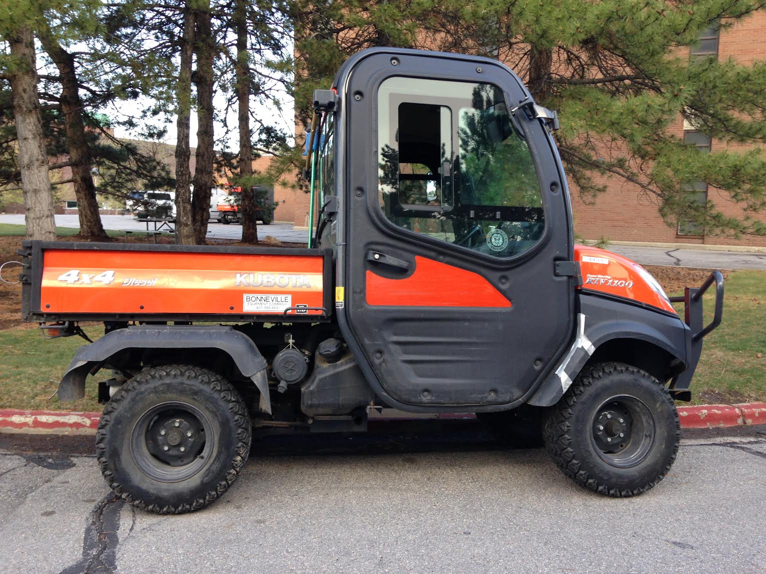

LRP Reader

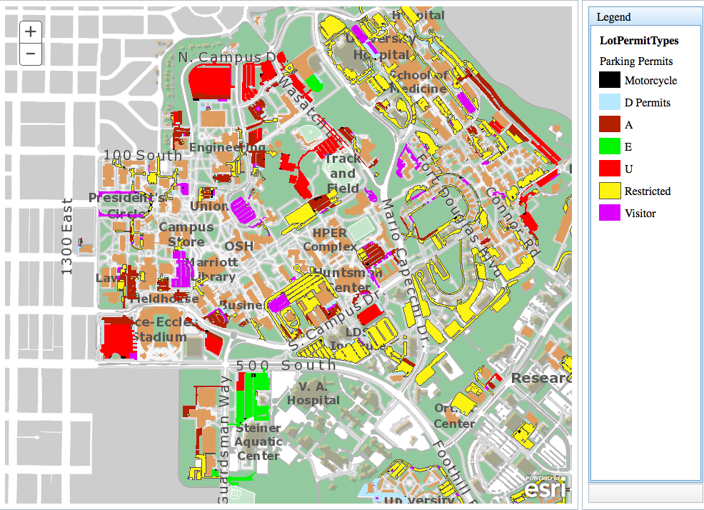

Map of Parking lots

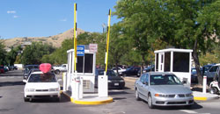

Paid parking lots

Financial Aid and Scholarships
- The Student Services building (http://www.utah.edu/students/services.php) provides numerous resources and services created to help students prosper during their time at the U. One of the offices that it houses, are the offices of Financial Aid and Scholarships (http://financialaid.utah.edu/).
- The Student Services building maintains their data with the Register’s Office of the University, the information held within their database include.
- Name
- Age
- Address
- SSN
- Financial Information
- FAFSA Information (Federal Aid)
- In regards of Financial Aid and Scholarship the students’ information, as well as the Financial and Scholarship information, is in the main University database. This information is encrypted into the school system, and, as stated later, only certain units have access to it. Students information regards:
- Finance
- Loans
- Class Registration
- Pell grant
- Scholarships
- Work Study
- This information is for the University of Utah’s own knowledge, this information is secured and is only shared in departments of interest such as scholarships, however if a student were to transfer the information would then be transferred over to that school database. The only other person with access to the information would be the student themselves.
- This information is collected in order to assist the student within financial questions and concern but also for the school’s personal knowledge that the student has paid for their education.
- Within the school database, students can view the main headings of their information within their school login.
- The students information is collected electronically and is given by the student when he/she registered via Canvas. Other Associated contacts in regards of students information include.
  - Registrar's Office
  - Scholarship Office
  - Financial Aid Office
  - Student Loan Office
  - Transfer Student Office
  - University Scholarship Office
  - Student Affairs (Work-Study)
- The authorized position to access a student's personal information (Name, Age, Address, SSN, Financial Information, FAFSA information) include:
- Manager of Athletic Financial Aid
- Scholarship Program Manager
- Scholarship Associate Director
- Manager of Student Services
- Financial Aid Counselors
- Accounting Specialist
- Director of Administration
- Financial Aid Specialist
- The authorized employees may gain access personal information that is on and off the financial aid application. Those with authorization use an un-named software in order to look at students personal information that is not on the application. The information is seeked for when potential or registered students do not answer correctly and for other purposes.
- The information collected on behalf of the student (financial information, SSN, Name, Age, Address, FAFSA information) is titled as a “student record” and is thus subject to FERPA. This information is used to help the students with questions about finance, FAFSA, semester registration, and, depending on the student’s GPA, whether they are available for scholarships, their availability to receive scholarships, and apply them to their school bill.
- During the process of the FAFSA application, there tends to be a problem of where the financial aid will go. The problem only happens to a handful of students a semester. The problem is when some students enter their information, they tend not to check if all the information given is correct. For example, when a student puts in the incorrect social security number the FAFSA does not recognize the number with the student and continually loads. Students are unaware when this problem rises, until someone with authorization sees their profile and notices that the application is continuingly loading. The student is then called to be made aware and give correct information.
- Work Study is part of Financial Aid. Students and employers must understand and agree to follow work-study policies before committing to participation in the work-study program. The information of the student obtaining employment on campus is kept in the main University database.
- The information is kept depending on how long the student is registered within the school system. This information is renewed/reauthorized each school semester.

A. Ray Olpin Student Union
1. Video Camera Surveillance*
- Surveillance cameras are located throughout the Union building and only record visuals.
- There are currently 48 cameras located within the Union building; however, they are planning to update their system in the next few months. This update will include some new cameras as well as the discontinuation of some cameras.
- Footage is collected for a few reasons.
- Times when people enter the building
- Entrances/exits that are most often used
- Safety of those within the building
- Not to waste utilities
- Video technology is simple as it is mainly used for the protection of property—no facial recognition
- Footage is stored digitally within the building. There is no central control room where the cameras are being monitored in real time.
- It is available for 10 days and then self deletes.
- The information is protected from unauthorized access by:
- Requiring specific logins for all employees with access
- Logins change monthly and are determined by the building administrators
- All footage is encrypted
- Cannot be accessed off campus
- Firewalls
- No search warrant or subpoena is needed to view the information collected by the surveillance camera.
- Ex: If you had a bag stolen, simply ask to see the footage from that day. A manager will then review the footage with you.
2. Infrared People Counters
- Infrared people counters are located at every entrance.
- This only registers the passage of being that comes in or out of the building.
- These infrared people counters monitor when and how many people enter the building so that administrators know when the building needs to be open. This helps them to more efficiently distribute funding.
- Both information gathering systems can be accessed by any of the building and student managers, as well as the building administration.

* Although we were able to obtain building floor plans which showed the location of each camera, we have elected, for security reasons, not to include the floor plans in our report.
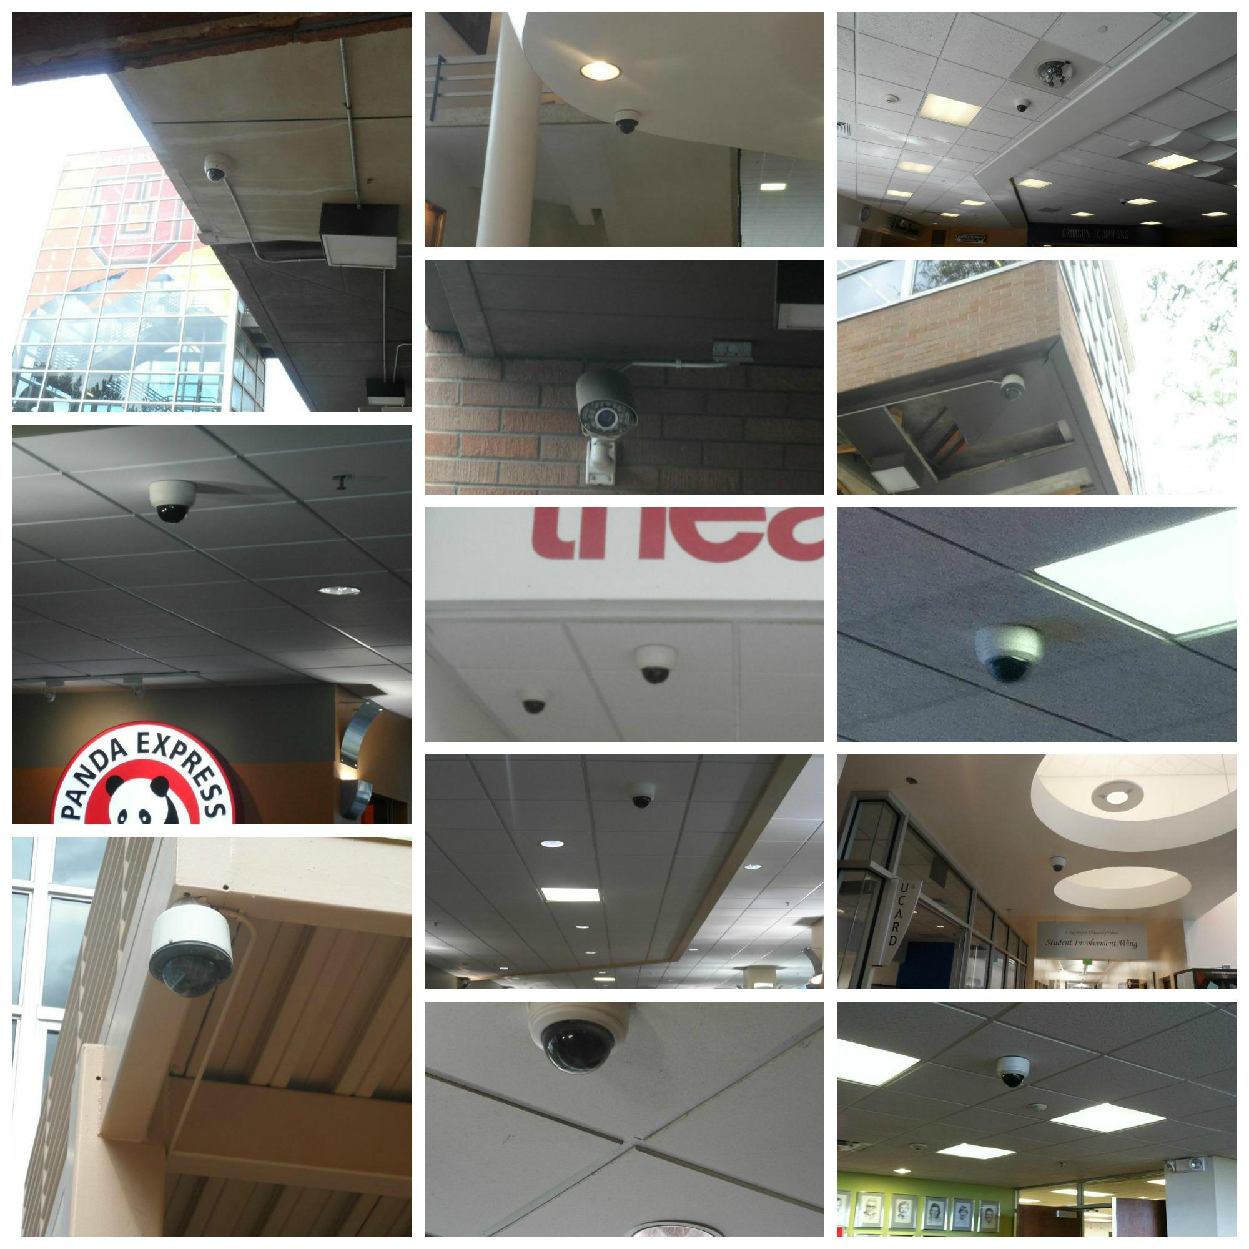
These photos show various video surveillance cameras that are located throughout the interior and exterior of the Union building.

J. Willard Marriott Library
1. The Marriott Library is centrally located on campus and is one of 3 libraries at the University. It is the main library and has approximately 1,818, 841 visitors each year. A brief description of the library’s information gathering systems are listed below:
2. Aleph—Integrated Library System
- Used to track when any of the 3.5 million items are checked out, returned, recalled, or associated with any fines
- Information connects a patron’s uNID
- Entrances/exits that are most often used
- Safety of those within the building
- Information collected because the library is a public institution, owned by the state of Utah. This requires them to keep track of where their assets are so that they can report to the auditor and insurer. Funding is then based upon this data.
- Being “checked-out” doesn’t show personal information, it merely shows that the item is not in the library but is checked out by either faculty or student
- It is all collected for inventory control
- Anyone can access their own information by using their uNID on any computer
- The information is available for as long as the transaction is open.
- All closed or completed transactions including checkouts, fulfilled requests, fines paid, bills paid are purged after 30 days of closing.
3. 3M Security Gates
- ADA compliant security gates that beeps when library material is being removed without checkout.
- Also counts number of people entering and exiting the building
- Helps with funding, planning, and communicating with the University’s custodial help
- No personally identifiable information is collected
- The information is given to the university administration and is posted on the Marriott Library’s website
- Information is kept electronically and in perpetuity to show trends in library use.
4. C*Cure Security Management
- This system monitors events, manages personnel access, creates reports, and monitors system activity..
- Allows access for certain people to certain places
- Special collections—only 38 of the library staff have access
- Graduate student reading rooms
- Family reading rooms
- Swipe their UCARD, access is given through this system
- Electronically records the date, time, location, and name of who scanned
- The primary purpose is to prevent unauthorized access to restricted areas
- Information is accessible to library staff for 60 days
- Kept on the campus server
- Staff have a unique login
- Staff must sign the University’s Confidentiality and Acceptable Use Agreement to insure no abuse of this information
- Campus Facilities Management monitors access and enforces compliance
- The UCARD office backs up the information for another 60 days
- However, the information is not accessible to library staff
5. Surveillance Cameras
- The Library uses IP based cameras
- Are used to help in closing, due to lack of staff
- Used to prevent crimes such as theft or lewdness
- A check system to the C*C system
- Do not have facial recognition or audio
- 5 pixels with 1 meg resolution
- Footage is accessible for up to 30 days
- System is self regulated—purges data
- Cannot manually override the purging system, but can export video if it is needed
- Footage is stored within the library, not with campus police, because the library believes patrons should have intellectual freedom
- Cameras are running in the security manager office with monitors displaying live time
- Can be accessed by University UCARD administrators and full time Library Security staff
- Same access security measures that are used for the C*C system are also utilized for the surveillance cameras
6. Guest Passes
- Guest passes temporarily assign visitors a uNID so that they can use the library computers
- Gives them access for up to 24 hours
- Logins are refreshed so they can be reused
- Information in handwritten
- To be eligible, University Policy requires:
- Full name
- Number from a government issued ID and the expiration date
- Guest pass logs are kept for 6 months and can be accessed by full time Library Security Staff
- Completed and in process logs are secured in separate storage areas
7. Computers/Wifi
- Browsers have no filter due to intellectual pursuit and freedom.
- Information is only available that day, while the session is open
- Computers purge your browsing history once you logout
- Your uNID is removed, but the library can see that a student or guest used the computer and at what time
8. Picture Policy
- The library has a courtesy policy that says if you wish to take a picture, you need to speak with security just so security officers can warn patrons. This gives them the opportunity to leave or move if they do not wish to be in the picture.
- It is legal to take pictures without asking because the library is a public building; however, in trying to protect the intellectual freedom of the patrons, the library would prefer that the courtesy policy is followed.
- Our pictures were taken from the Library’s website and merely show a surveillance camera and an area restricted to certain people that get access through swiping their UCARD.

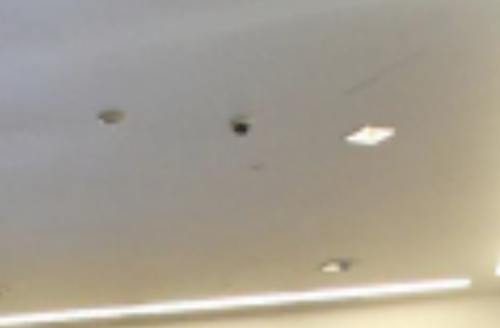
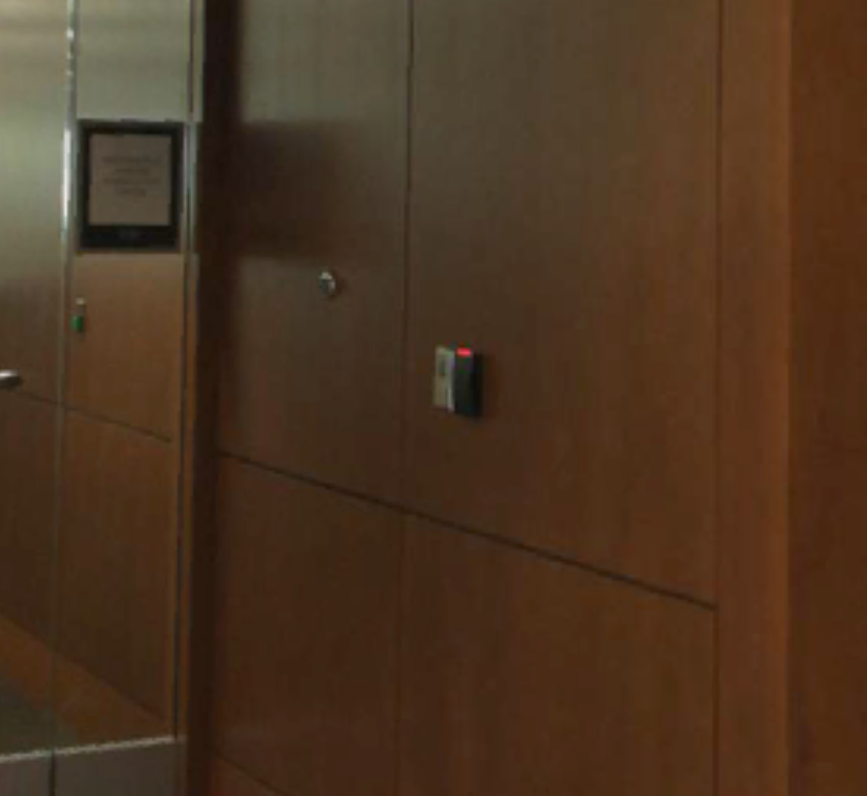
These photos were taken from the Marriott Library’s website, using their interactive maps. This is the link to these maps: http://www.lib.utah.edu/maps-alive/page8.htm

Note: We are pleased to report that as a direct result of this project, the Marriott Library has adopted a formal privacy policy governing the handling of data at the library.

Athletic Teams - Men’s Basketball Team
1. Medical:
- Each trainer, for each sport, keeps the information. Information collected includes but is not limited to all health insurance, physicals, drug tests. The doctors up at the University of Utah Healthcare also keep records.Trainers can also access all of the information that the doctors collect; however, they do not store them in their offices and usually just let the doctors keep it.
- GA’s (graduate assistants) are allowed access to the information, because they have been certified to become athletic trainers. Student athletic trainers, however, have not been certified and thus are allowed no access to the records (digital or paper).
- Coaches are notified by trainers when a player has some sort of an injury. Coaches have no need to see the players’ injury file, and thus have no access. However, athletes do sign a waiver that allows trainers to discuss their medical conditions with coaches so that trainers are not in violation of HIPPA.
- Doctors are allowed to view records on a needs basis to treat players.
- Compliance also has access to very specific information, such as drug testing results. Compliance is notified by the trainer, and then notifies the coaches. The coaches and player would then work to overcome the drug use with compliance.
- Paper files are kept and stored in locked filing cabinets in the offices of the trainers. The Athletic Training Department is required by legal rules to keep the files for at least 7 years, but as a precaution, have kept paper files up to 12 years.
- Trainers also use Presagia Sports (pictured on the top of the next page) to keep information such as injury tracking. Presagia was purchased by the Athletic Department. The information on it is prohibited from being sold by law, and is also encrypted. The information is kept on Presagia’s servers. They have multiple servers around the world, that way if one server goes out, you can still access your information. The information, according to Presagia's website, is permanently accessible. More information on Presagia can be found on their website: http://www.presagiasports.com
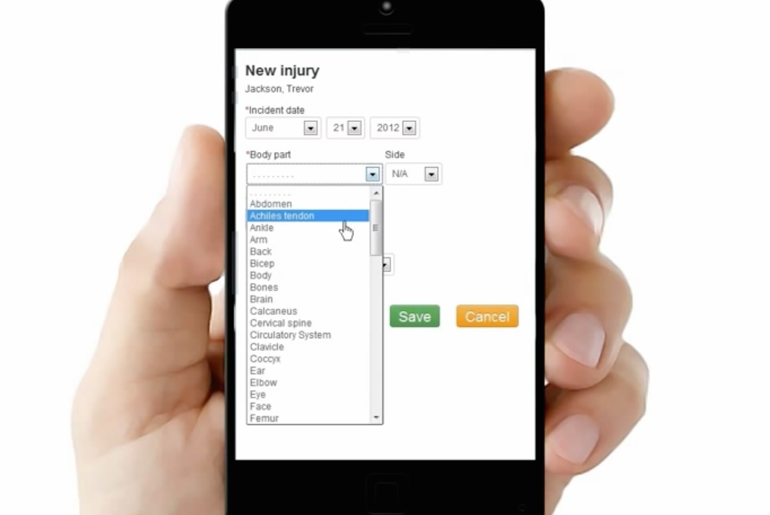
- Information does have a secondary use: trainers use past injury reports to handle injuries that come up. However, names are not associated with the reuse of this data.

2. Academics:
- The Academic Services for the Athletics Department collects all of the student-athletes’ academic information. This includes class schedules, course grades, term and cumulative GPA's.
- They collect this information on an individual basis; it can vary depending on the student-athlete’s need. It can vary from once a semester to once a week.
- They call students to meet with them if they have poor academic performance or if they are interested in participating in academic advising. According to NCAA, student-athletes must maintain a 2.0 GPA.
- They use the University's PeopleSoft system to collect their information. Employees (of Athletic Academic Services) go through the web security training to receive access to review information within the University's record keeping system. PeopleSoft is accessed via CIS login and password, as well as other types of login and passwords for the various data bases. Individuals that have been granted access to PeopleSoft can view different information; however, their authorization depends on what they can access.
- All of the information that they use is maintained by the University, and so, the University’s policies and procedures would be followed if there were an information breach.

3. Social Media:
- At the beginning of the year, student-athletes complete NCAA and institutional forms that collect contact information (e.g., address, phone, email, etc). The student-athletes also fill out social media profile information. This information is collected on a form that is kept on file in the coach’s office. Coaches also collect information on the parents of players, such as contact information. Assistant Men’s Basketball Coach Phil Cullen keeps all data collected is saved electronically on a spreadsheet and also as a hard copy saved in his files.
- Compliance randomly monitors social media watching for issues that may violate NCAA rules.
- Cullen is primarily in charge of watching social media. He has chosen to only monitor Twitter saying that, “The information on Twitter seems to be a credible resource for news and information more so than the other media outlets.”
- Compliance watches for any activity that might violate a NCAA rule, for example a recruiting violation, would require compliance to call in a player and have a conversation with him about it.
- Cullen watches for anything that takes away from team goals that are decided by the players and coaches. He also said that they as coaches have made it a point to remind the players that should also be good examples on social media in an academic way .
- Coaches that wish to view what compliance has collected are allowed to view what they have collected..
- Similarly to student-athletes, compliance monitors social media activity of coaches randomly. Cullen says that the staff uses social media more as a resource to see what is up with the kids they are recruiting and also their current players. On occasion a post will be made but they are representing their university so their post are more about promoting the team and program. It is a recruiting tool as well. They have several social media outlets within their department that they will reference and have a people hired full time that look over the whole department.
- Compliance does not collect information from fans. They do however randomly check social media for issues that could violate NCAA rules based on what has been posted to social media that is viewable to our office.
- All athletics Compliance staff members also have access to the information that is collected.
- The information is kept in a digital form on the private university network drive.
- Compliance does not actually have any protocol for an information hack; however, they said that should something of the sort happen, they would consult with their IT staff.

4. TeamSynced**:
- The team uses TeamSynced to schedule practices and other team activities that will work with the various schedules each person has. TeamSynced works like a calendar and displays everyone’s schedule and allows coaches, trainers, and certain team personnel to add events or videos that the players must attend or watch. All of the players give their class schedules to Cullen, who entered them into the program.
- There is little personal information on TeamSynced other than class schedules.
- Only team personnel, players, coaches, trainer, academic advisor, strength coach and administration have access to that information. They each have the app on their phone and only get access through a password.

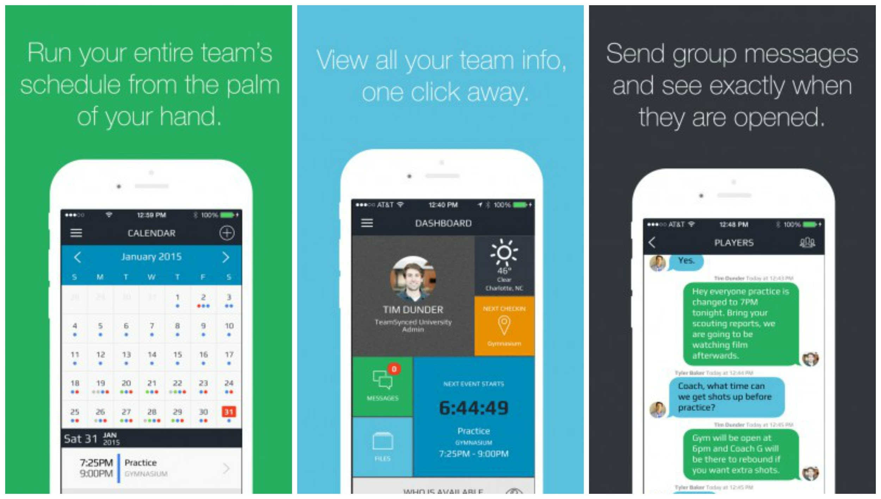
*TeamSynced photos courtesy of their website: teamsynced.com, and Presagia Sports photo is courtesy of it’s website: http://www.presagiasports.com
**All of the things that are done by Compliance and the Academic Services apply to all of the athletic teams; however, the way that coaches monitor their teams vary between teams. For example, not all teams use TeamSynced.

Block U
- The Block U is an honorary learning community that thematically organizes courses that will allow undergraduates to complete their General Education Requirements within the first two semesters. Ann Darling, Associate Dean of Undergraduate Studies, is the head of and in charge of the Block U program. Andrea Haag, Coordinator and Administrative PR for Undergraduate Studies, manages student information and the Block U database.
- There are seven different BlockU programs at the University of Utah
  - Arts and Advocacy, Entrepreneurship and Society, Families and Health, Global Citizenship, Privacy and Surveillance, Health, Food and Social Justice
  - For more information:
    - The Block U website: http://ugs.utah.edu/blocku/
    - Privacy and Surveillance Block U website: http://ugs.utah.edu/blocku/privacy.php
- Information is kept in a database
  - They have students general information and a picture
  - The information is given to the Block U program from the admissions office for the students in the New University Scholars program, and from the other individuals that sign up for Block U.
  - The information is kept in a program called PeopleSoft to alert others of Block U status.
- Who gets access?
  - Andrea Haag, Coordinator and Administrative PR for undergraduate studies, is the only person who has access to this information. Ann Darling, Associate Dean of Undergraduate Studies, is unable to view the information.
  - The information is all kept electronically and is password protected.
- The length of time that the information is kept is still undecided because the program is only two years old.
  - They will keep it for at least four years because they want to track the graduation progress of the students.
  - For students that drop the program, there name and UID is kept in the database.
    - This is used to make statistics about the program.
- Why do they collect this information?
  - It is collected to check grades and credit hours, but it is not recorded.

School Of Medicine (Learning Resource Center)
- The University’s School Of Medicine (SOM) was established in 1905, and is a four-year medical program. It has 22 clinical and basic-science departments that train the majority of Utah physicians, from M.D. degrees to residencies, to fellowship speciality training. More information on the School Of Medicine can be found at its website: http://medicine.utah.edu
- Part of the School Of Medicine is the Learning Resource Center. The Learning Resource Center develops and maintains a wide range of academic programs and services in effort to provide academic guidance and assistance. These programs require that they collect information from the students, making it one of the many organizations within the School Of Medicine that gathers information. The following includes the specifics on the collection and maintenance of the information. (More information can be found at http://medicine.utah.edu/learningresources/contact/index.php.)
- The Learning Resource Center collects academic information throughout the course of the graduate students’ 4-years of study, biographical information as part of the admissions process, other graduation information related to national guidelines and standards for becoming a licensed medical professional (for example, performance on national exams), evaluative date that students are asked to complete about their courses, and individuals they work with in clinical settings (for example, students are asked to evaluate doctors that are teaching them clinical information).
- Academic information is collected throughout the year for grading purposes, dependent on when courses are held (SOM calendar is a bit different than the undergraduate academic calendar).
- Biographical information is collected as part of the admissions process and is updated as needed (for example, change in address, phone number, marital status). Rainey says that he would imagine the information is kept in perpetuity either in a database, or hard copies in a file for each student. The hard copies are kept on-site initially and then are archived after a student graduates.
- The graduate students would be called in to meet with someone in the Learning Resource center for poor academic performance, behavior that is deemed unprofessional (for example, mistreating a nurse or fellow student), and students are asked to provide evaluative information about their educational experience.
- The mechanisms used to gather this information include admission applications, exam software, data entry, individual student files.
- In regards to access to the information, FERPA standards are followed. Various units within the School of Medicine are able to view different bits and pieces of information that are relevant to their jobs and working with students.
- PeopleSoft is used to keep information, as well as individual databases. This electronic information is accessed via CIS login and password, as well as other types of login and passwords for the various data bases. Individuals will have different authorization based on need to see information.
- Individual student files are maintained where hard copies of information would be filed.
- Students are taped performing patient interaction exams (called OSCEs). Videos are kept in some type of BOX data base and the IT folks will screen employees that request to see them.
- If there is an information breach, SOM IT group would be the ones that would handle it, not the people at the Learning Resource Center

Appendix A

Andrea Haag……………………………………...Coordinator, Administrative Program
Ann Darling………………………………………….………………….Associate Dean
Braden Dalley…….....Associate Director of Operations for the Student Union Building
Erik Weierholt………….Director of Academic Services for the Athletics Department
Ian Godfrey……………………………….Director, Ops & Logistics Marriott Library
Patricia Alexander………………………....Administrative Assistant Financial Aid Office
Phil Cullen………………………………...………...Assistant Men’s Basketball Coach
Robert Rainey…………………………………………….....Director, Student Services
Trevor Jameson…………………………………………...Director of Athletic Training
Zak Pendleton…………………………………………...…..Compliance Representative

